**Engineering Explorer Post 1010**

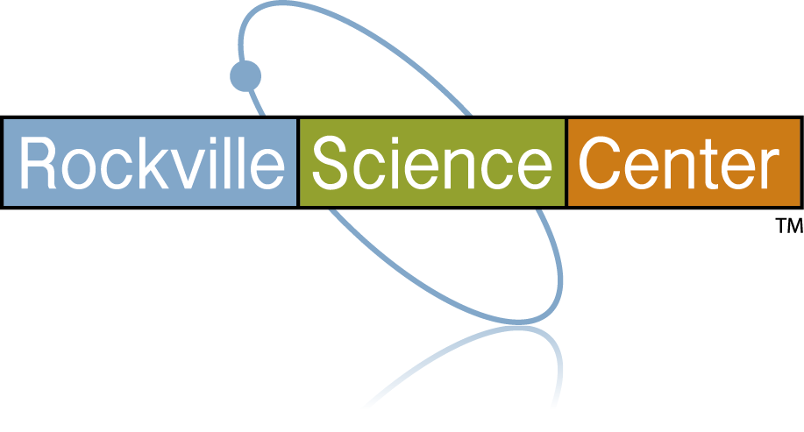

Explorer Post 1010, sponsored by **Rockville Science Center**, has an exciting program of technical and fun activities for high school students interested in engineering.

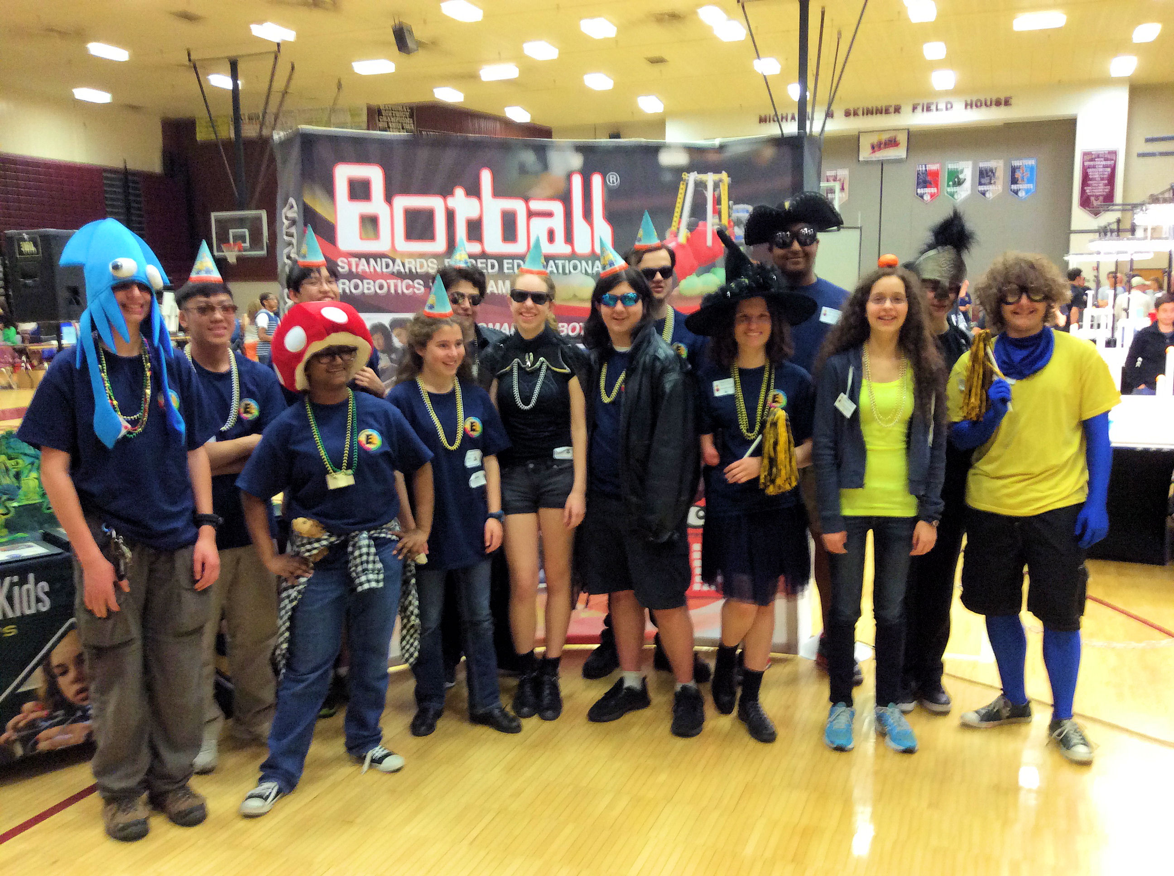

We have technical presentations, go on tours, and sometimes play games, all with the objective of giving teens some hands-on experiences in engineering disciplines. We are engaged in four student engineering projects - *The American Rocketry Challenge, FIRST Tech Challenge Robotics,* *Botball Educational Robotics,* and the *UAS4STEM Drone Competition*.

The members get opportunities to develop both leadership and teamwork skills. Projects, and teams within projects, define their structures and leadership. We also participate in service projects at the Rockville Science Center and in the community. We have many opportunities to earn Student Service-Learning hours.

We enroll about 40 teens every fall and run the program through the next summer. Most members are involved for three or four years. This post has been active since 1997. We were at Lockheed Martin for 17 years, spent five years at Johns Hopkins University in Montgomery County, then moved to the Rockville Memorial Library, and then finally we moved to the Science Center facilities. We’ve had over 600 teens participate through the years.

**Meetings**

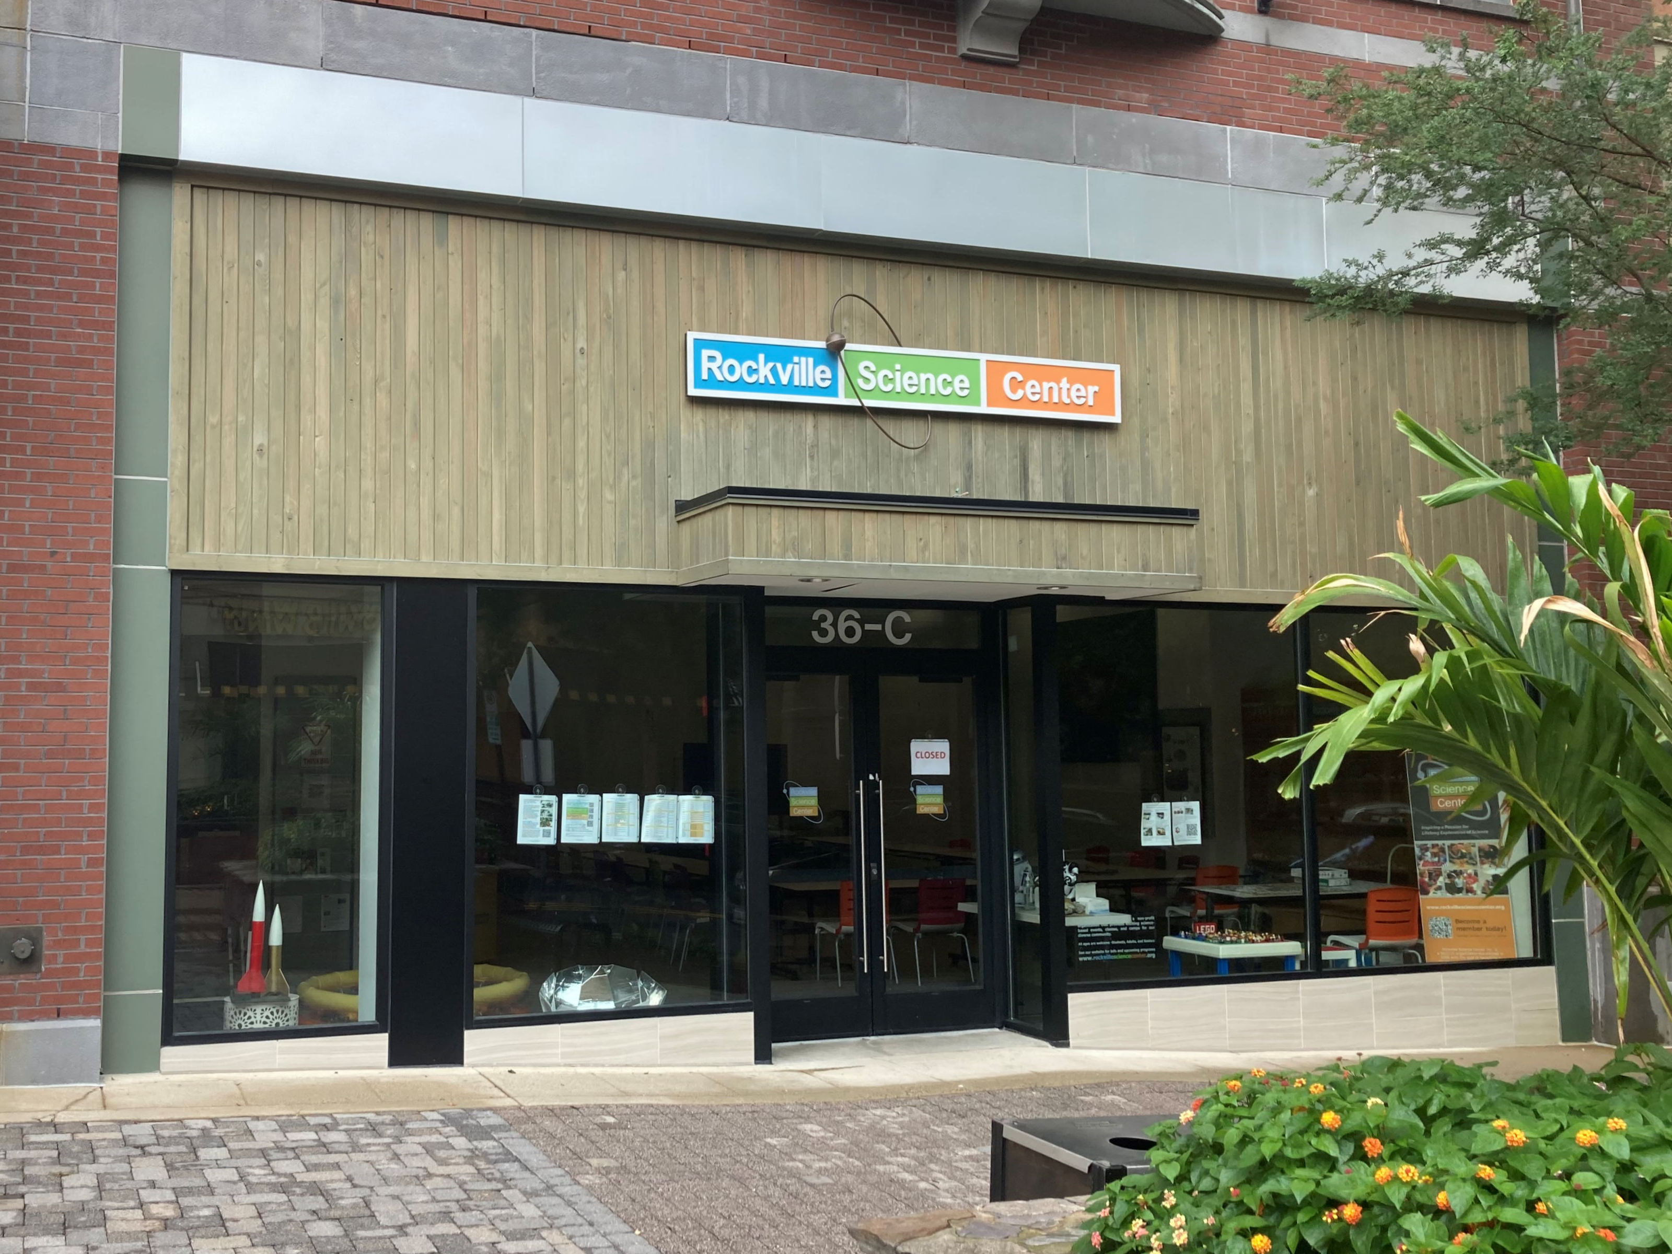

The post meets on Wednesday evenings, 7:00 to 9:00 pm. Project teams meet at other times determined by the teams, usually Monday evenings and Saturdays. Tournaments and flying rockets and drones are on Saturdays and Sundays. We go on field trips usually on days when schools are off. We maintain a calendar on our web site. We meet at the **Rockville Science Center, Makerspace**, at 33F Maryland Ave and the Center’s **Storefront** at 36C Maryland Ave, Rockville, Maryland, 20850.

**Staffing and Funding**

The post is staffed by volunteers, parents, and others interested in helping shape the next generation of engineers. We need help from parents with chaperoning, driving to events, and providing snacks. Parents are needed to help with the programs. Project costs are funded through dues, contributions, grants, and fund raisers. Dues are $300 annually, collected by November. A membership form and national application form, signed by the parent or guardian is required. Project/team membership require additional registration forms. Costs associated with travel and field trips are covered by individual members.

**Contacts**

Our web site at <http://www.post1010.org> is the main source of information about the post. We have email lists for members, parents, and advisors. We have several closed Facebook groups for sharing operations information and activities. Some of the teams have additional on-line channels. We are organized under the national Exploring organization and associated with the National Capital Area Council of the Boy Scouts of America.

Bob Ekman at Rockville Science Center  
email: [info@post1010.org](mailto:info@post1010.org)  
phone: 301-512-1278

