Lockheed Martin
Exploring Program
Post 1010
March 23, 2005

Botball Robotics Design Proposal

Team ______

Designers:

__________________________________________

__________________________________________

__________________________________________

__________________________________________

Robot Names:

__________________________________________

__________________________________________

__________________________________________

1. Game Strategy:

Maximum Points Scored: __________ XBC __________ Handyboard __________
Difficulty (scale 1-10): __________ XBC __________ Handyboard __________

_____________________________________________________________________

_____________________________________________________________________

_____________________________________________________________________

_____________________________________________________________________

_____________________________________________________________________

_____________________________________________________________________

Diagrams:

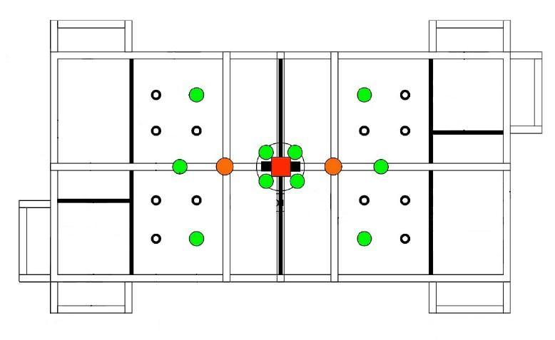

2. Mechanical Design:

Handyboard [_] Wheels [_] Treads [_] Grabber [_] Pusher [_]

XBC [_] Wheels [_] Treads [_] Grabber [_] Pusher [_]

_____________________________________________________________________

_____________________________________________________________________

_____________________________________________________________________

_____________________________________________________________________

Diagrams:

3. Software Design:

_____________________________________________________________________

_____________________________________________________________________

_____________________________________________________________________

_____________________________________________________________________

_____________________________________________________________________

_____________________________________________________________________

_____________________________________________________________________

_____________________________________________________________________

_____________________________________________________________________

_____________________________________________________________________

_____________________________________________________________________

_____________________________________________________________________

_____________________________________________________________________

_____________________________________________________________________

_____________________________________________________________________

_____________________________________________________________________

_____________________________________________________________________

_____________________________________________________________________

_____________________________________________________________________

_____________________________________________________________________

_____________________________________________________________________

_____________________________________________________________________

_____________________________________________________________________

_____________________________________________________________________

4. Testing Procedures:

_____________________________________________________________________

_____________________________________________________________________

_____________________________________________________________________

_____________________________________________________________________

_____________________________________________________________________

_____________________________________________________________________

_____________________________________________________________________

_____________________________________________________________________

_____________________________________________________________________

_____________________________________________________________________

_____________________________________________________________________

_____________________________________________________________________

_____________________________________________________________________

_____________________________________________________________________

_____________________________________________________________________

_____________________________________________________________________

_____________________________________________________________________

_____________________________________________________________________

_____________________________________________________________________

5. Schedule: (Break down the team strategy into at least 5 tasks)

Task | Start Date | End Date | Who

