Lockheed Martin
Exploring Program
Post 1010
March 15, 2006

Botball Robotics Design Proposal

Team Number 1 2 3 4 5 6

Team Members | Assignments

Team Organization:

_____________________________________________________________________

_____________________________________________________________________

_____________________________________________________________________

_____________________________________________________________________

_____________________________________________________________________

Team Goals:

_____________________________________________________________________

_____________________________________________________________________

_____________________________________________________________________

_____________________________________________________________________

_____________________________________________________________________

Game Strategy:

Maximum Points Scored: __________ XBC 1 __________ XBC 2 __________
Difficulty (scale 1-10): __________ XBC 1 __________ XBC 2 __________

_____________________________________________________________________

_____________________________________________________________________

_____________________________________________________________________

_____________________________________________________________________

_____________________________________________________________________

_____________________________________________________________________

_____________________________________________________________________

_____________________________________________________________________

Navigation:

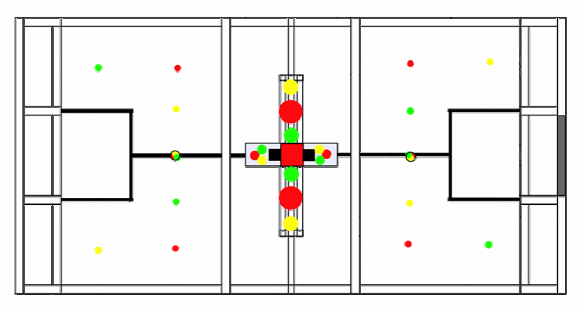

Mechanical Design:

Wheels [_] Treads [_] Grabber [_] Pusher [_] Camera [_] Sonar [_]
Motor Count: Black Motors ____ White Motors ____ Gray Motors ____
Servo Count ____ Touch Sensor Count ____ Line Sensor Count ____
_____________________________________________________________________

_____________________________________________________________________

_____________________________________________________________________

_____________________________________________________________________

Diagrams:

Software Design:

_____________________________________________________________________

_____________________________________________________________________

_____________________________________________________________________

_____________________________________________________________________

_____________________________________________________________________

_____________________________________________________________________

_____________________________________________________________________

_____________________________________________________________________

_____________________________________________________________________

_____________________________________________________________________

_____________________________________________________________________

_____________________________________________________________________

_____________________________________________________________________

_____________________________________________________________________

_____________________________________________________________________

_____________________________________________________________________

_____________________________________________________________________

_____________________________________________________________________

_____________________________________________________________________

_____________________________________________________________________

_____________________________________________________________________

_____________________________________________________________________

_____________________________________________________________________

_____________________________________________________________________

Testing Procedures:

_____________________________________________________________________

_____________________________________________________________________

_____________________________________________________________________

_____________________________________________________________________

_____________________________________________________________________

_____________________________________________________________________

_____________________________________________________________________

_____________________________________________________________________

_____________________________________________________________________

_____________________________________________________________________

_____________________________________________________________________

_____________________________________________________________________

_____________________________________________________________________

_____________________________________________________________________

_____________________________________________________________________

_____________________________________________________________________

_____________________________________________________________________

_____________________________________________________________________

_____________________________________________________________________

Milestones: (Break down the team strategy into at least 5 milestones)

Milestones | Start Date | End Date | Who

