Lessons Learned
Team 196
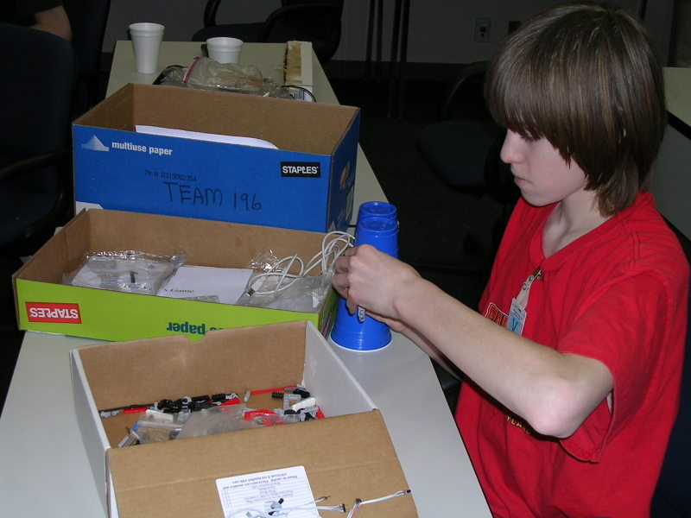
From the beginning, there was Team 196, and all was well.
Well, that's not exactly how it happened. Yes, from the beginning there was a Team 196 – fourteen students from a variety of school picked almost randomly out from the 42 students in the Lockheed Martin Explorer Post, but the Team 196 at the beginning of the Botball experience was nothing like the team which came together through the preparations for the competition. The group of high school kids who were thrown together randomly at the beginning of the competition eventually came together to form a successful Botball team.
We had a few problems at the beginning including division of parts, fewer jobs than members, and our biggest: staying on task. With multiple people with the same strengths, and only two robots to work on, it was difficult to organize people into successful teams. Our team was almost twice as big as last year’s team, and we had more member than we knew what to do with. And, although there was plenty of work to be done, we had initial trouble with motivation. We spent half of our first meeting discussing names for our two robots. We clearly had organizational problems, but we felt pretty relaxed. After all, the competition was six weeks away, and we had ample time to figure things out.
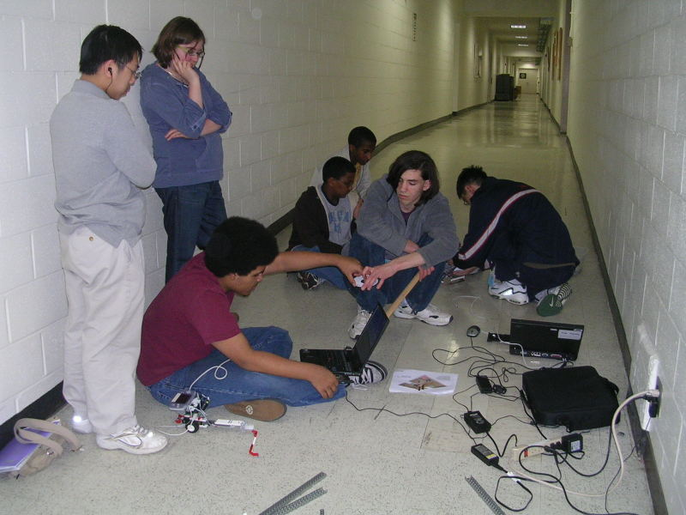
Once the first week has passed by, we realized that we still had much left to do and that we needed to get organized, and quickly, if we wanted to succeed in this year’s competition. Our project plan was the first step to turning our team into a well-oiled machine. We all now had clear guidelines, tasks, and sub teams – one for each robot. With these goals in mind, we set to work. To our surprise, we found that, with our new organization, we could actually make progress on our robots. A new atmosphere set in, and we began to bond with our teammates, some of whom were distant acquaintances and the others who lived across the county, and whom we would never see outside of Botball.
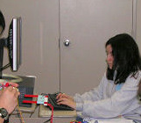
So we learned a number of things from our Botball experience. We learned the value of organizational tools in helping us complete assigned tasks. Setting concrete and well-defined goals for ourselves actually helped us see various projects through to completion. Assigning specific people to specific tasks also helped: it kept the members of the team constantly active and out of each other’s ways. Everyone got a chance to exercise their strengths, whether that strength was supervising, testing, coding, or documenting. In addition, once our team began to function as a cohesive unit, we learned exactly how powerful teamwork could be. We became friends with people whom we otherwise never would have met.
Documentation was also a valuable part of the Botball experience for almost every member of the team. The two primary documenters worked closely with others on the team, who consistently provided us with test data, and even took more involved roles, such as providing us with in-depth descriptions of the functions of each mechanism of the robots when we created our PowerPoint and commenting our code. Documentation projects such as the Project Plan helped our team to become even more organized and functional, and, with everyone exchanging information and aiding in the Documentation process, our Documentation projects helped to bring our team together. Documentation was also one of the few areas of the Botball competition which helped us improve our writing skills.
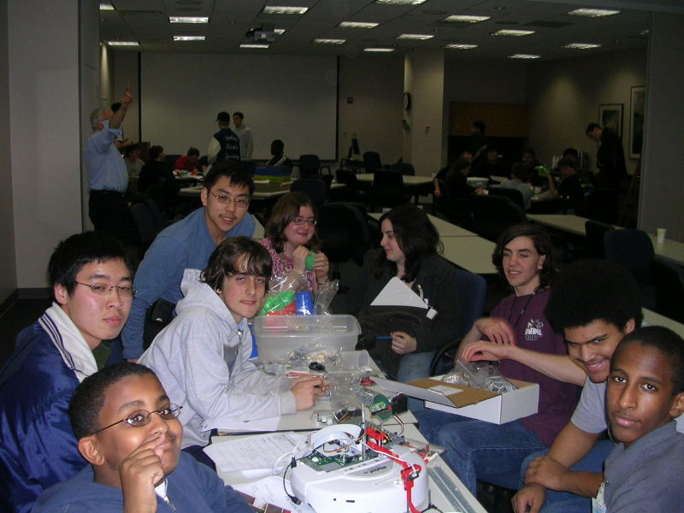
One of the most surprising elements of the Botball competition was that a team built on intellect alone would not succeed, as we learned in the early stages of our journey. The best teams are built on a combination of dedication, organization, drive, and, yes, some raw talent, as well as potential to learn. Our main advice to future teams would be to get organized early, because it will help them to stay ahead of the game every step of the way.
Regardless of how we do in the competition, the members of Team 196 are extremely proud of our accomplishments through the Botball season. The Botball experience has taught us all some valuable lessons which can be applied to other situations in life. We look forward to participating in this competition next year.

