Lockheed Martin Exploring Program
Explorer Post 1010
Beyond Botball Team

The Lunar Cleaners

For the fourth year straight, the adult advisors of Explorer Post 1010 are fielding a Beyond Botball team. Our teams have done very well in the past. We will see how it goes this year.
Bob Ekman is the team leader and the principal advisor for the post. Karen Kirby, a post parent, will help run the robots. Also running the robots will be Rodger Ding a graduated senior. Some of the other Botball team members may help as needed. Bob will leave before the final competition for his daughter's wedding.
The robots were designed, built and tested by many other post adults and high school members over the past six months. Many of the developers could not make the trip to Norman. We speculated and designed many solutions, but only implemented a few. Until we built a test board in June, it was difficult to understand the geometries of the problem and the behavior of the scoring objects.
We have two robots that will land on the moon near a South Pole crater. They are assigned the job of cleaning up before humans return to the moon. One robot, the LSC (Lunar Surface Cleaner), will work around a crater rim, picking up green and orange poms. It will deposit the poms in one of the remote landing stations, depending on which one is open. The second robot, the LCE (Lunar Cave Extractor), will enter a cave in the crater wall, looking for water and lost robots. It will return them to its landing station. While we are aware of aliens on the moon, our robots carefully avoid disturbing them. We have a third robot, the LBP (Lunar Base Protector), which may land later in the mission to protect the landing sites.

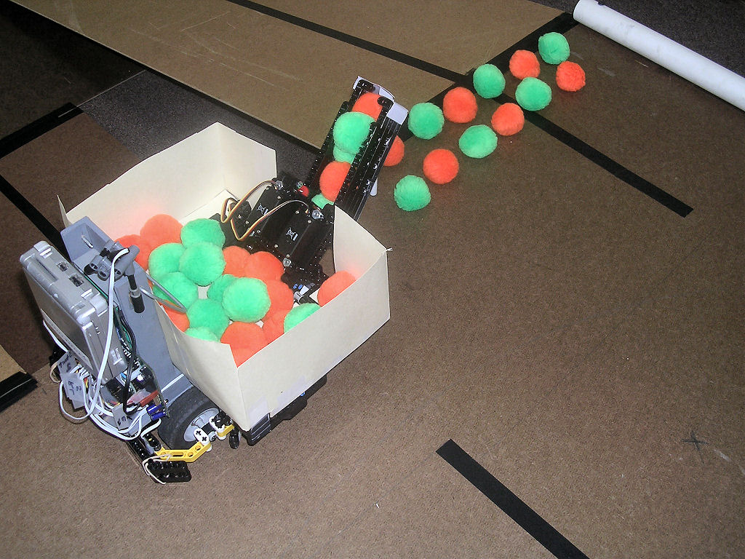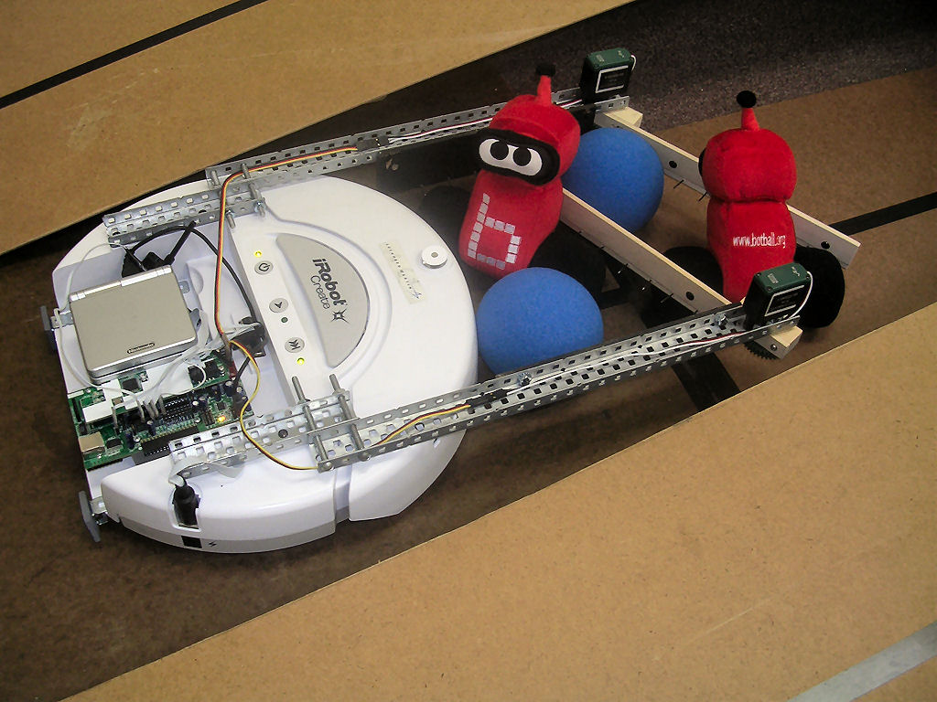
LSC - Lunar Surface Cleaner (aka Lucy) LCE - Lunar Cave Extractor (aka Lucky)
(not shown: LBP - Lunar Base Protector (aka Bouncer))

