Lockheed Martin Exploring Program
Explorer Post 1010 Botball Team 92

Our robots are named Huey and Dewey-Louie.

In the year 2108, our team, Team 92, comprising high-school students from Montgomery County, MD, was visiting a space station at the time a solar flare warning was received. As you know, all of earth’s plant life is extinct, except for a few specimens preserved in greenhouses orbiting the station. These are tended by agronomist robots, the Gardeners.

The station commander, B. Guy, and the senior farmer, G. H. Bluebody, decided that the plants and Gardeners must be brought into the safety of the station. We undertook the challenge of creating Huey, Dewey, and Louie, bots based on the agronomist robots featured in the centuries old (1972) classic documentary, “Silent Running”.

An emergency rescue mission was launched. Using search and rescue strategies developed a century before by our sponsor (Lockheed Martin in Gaithersburg, MD). Huey went on a dangerous mission to retrieve the plants and Gardeners from the unprotected section outside the station. Station workers created a rare double-wide entry ramp for Huey to use entering the space station. The wide ramp was needed to allow Huey to gather all of the plants and gardeners in a single excursion.

Following the successful rescue, the Gardeners and plants were separated, then processed according to their individual characteristics. Dewey and Louie ride together on an old platform made by iRobot used to clean the station. Louie placed all the plants and Gardeners in their safe zones. Dewey prepared four warning satellites and deployed them in space. When the solar flare danger passed, the Gardeners and plants were returned to their orbits around the space station, preserving plant life for another generation.

Shown observing Huey as it entered the space station with the plants and Gardeners are B. Guy and G.H. Bluebody.

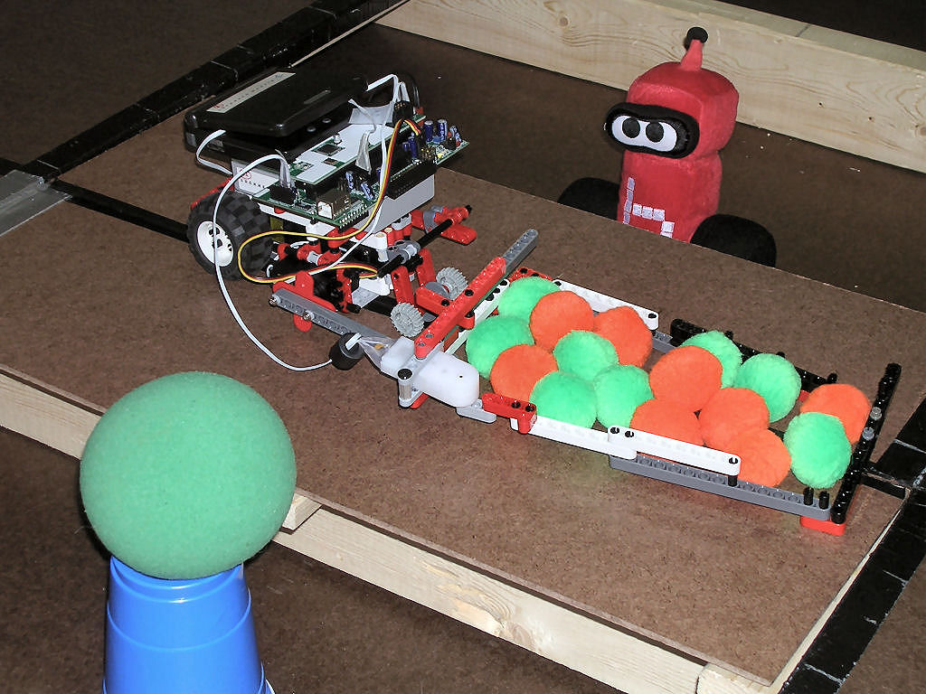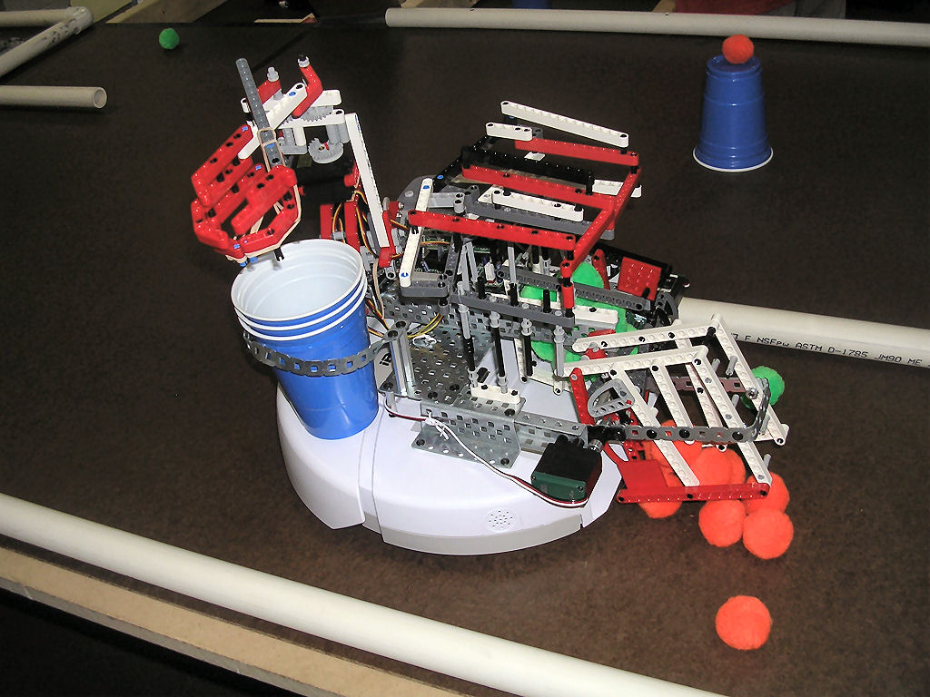
Huey, B. Guy, and G.H. Bluebody Dewey and Louie

(Excerpted from the Dead Garden Society’s newsletter)

