Lockheed Martin Exploring Program
Explorer Post 1010 Botball Team 93

Our bots worked great together as a team so we named them after comedy team Laurel and Hardy. Laurel is the skinny XBC robot, while Hardy is the large Create robot.
Our GCER Team 93 was integrated from regional teams 93 and 196. We found out that neither team would be completely able to attend, so the two teams started working together. For the Create robot, we elected to use Team 93's existing bot as it had near-perfect accuracy at sorting green and orange tribbles and taking them to the appropriate bins. We also decided to use their XBC chassis, though whose to use was irrelevant, since all our teams used the same basic chassis.

We also had a bridge blocker used in regionals, which we elected to modify and use, and hopefully make it more stable. It falls in front of their bridge on our side to (hopefully) block them from getting to where they could interfere with our affairs on our side of the board.

In addition to our old designs, we made some new additions as well. Though we used the basic XBC chassis from regionals, we did retrofit the XBC with a servo arm that moves vertically rather than horizontally and made 2 arms for the servo, one for seeding and one for competition. For the seeding rounds, we created an arm that effectively takes all four of their tribble piles and brings them all to our solarium. Though the orange tribbles are zero points in our solarium, they are still a net change of 1 for being taken from the other side. For the competition, we used an arm from team 196 which has a long piece of Lego attached to a white motor, capable of knocking tribbles and cups around but not off the board, and also capable of tripping up a Create on safe mode (we found this out by pure accident).

We have been working on a new bridge blocker. If we can get it to deploy correctly, it will fly into the center of the board (we need a method so as not to smack the lights and/or judges) and have a piece of metal to block the opposing bridge from completely falling down. If they send an XBC, provided it overcomes gravity, it would either fall off the side or flip over once it reaches the end of the bridge. If the other team sends a Create, the unequal bridges would get it stuck in way that at least one wheel would be off the ground.

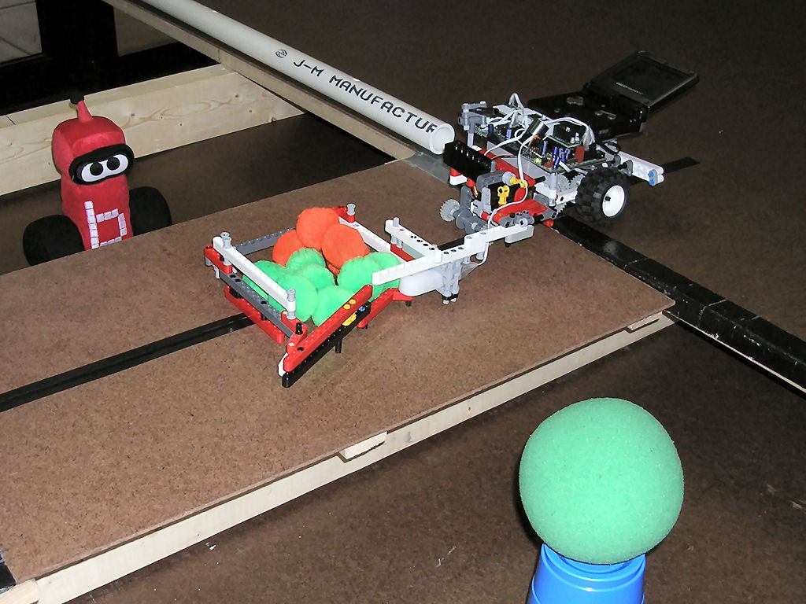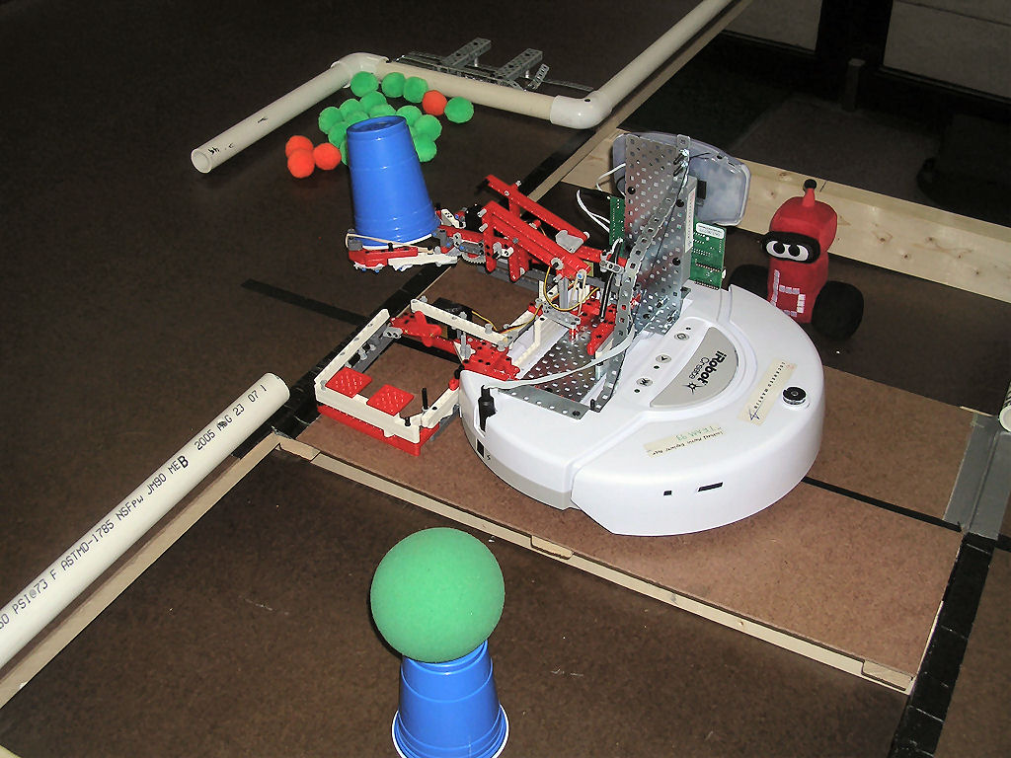
Laurel (thin) Hardy (fat)

