Beyond Botball 2008
Explorer Post 1010 Team
Lunar Cleaners
The Lunar Cleaners have three robots to help clean up the moon…
- LSC - Lunar Surface Cleaner (aka Lucy)
- LCE - Lunar Cave Extractor (aka Lucky)
- LBP - Lunar Base Protector (aka Bouncer)
Notes related to the following figure.
- Lucy and Lucky are used during seeding rounds. Bouncer is only used if there is an opponent bot in the upper starting box during competition.
- Shown are the left-side starting positions for seeding rounds or competition rounds when we are green.
- When we are orange in competition rounds, the bots start in the right side starting boxes.
- Setup for Lucky
  - Aligns to back pipe, somewhere in the middle. Since it aligns on a black line, the left-right alignment is not that important. But the alignment to the back pipe is very important.
  - The grabber arms must be folded in the grabber with the left short one in first.
  - When starting, you must select the turn direction out of the starting box. That is "Right" for seeding and green competition, and "Left" for orange competition when starting from the other lower starting box.
- Setup for Lucy
  - Aligns to back pipe, with the grabber arms down and fully open. The arms should be straight across, inside the box and about 1 inch from the left pipe (or right pipe when running orange). The center line sensor (under the arms) should be pointed right at the line coming out toward the bot.
  - When starting, you must select the turn direction out of the starting box. That is "Right" for seeding and green competition, and "Left" for orange competition when starting from the other upper starting box.
  - You also need to select the path to take after the poms are collected. You select "Lower" to go to the opponent's lower starting box, or "Upper" to go to the opponent's upper starting box. Never select "Upper" when the Bouncer is being used.
  - When you select "Lower" you will also need to select "Around" or "Direct". "Around" should be used during seeding and when there is no bot in the lower opponent's starting box. "Direct" (aka Suicide) is used during competition rounds when the upper and lower opponent starting boxes are used by the opponent. It will take Lucy into the lower starting box off the side of the ramp.
- Setup for Bouncer
  - Aligns inside the pipes in the upper starting box, along with Lucy.
  - Align the arm to have the blocker come down outside the opponents starting box, but the screw pin needs to come down just inside their box.
  - Once you align the arm, you need to freeze the position with the wedge. After you wedge it, manually try it one more time to insure alignment.
- Make sure all the starting light sensors are pointed at a starting light.
- When you calibrate the starting light sensors, make sure your arm or clothing are not in between the light and the sensor.

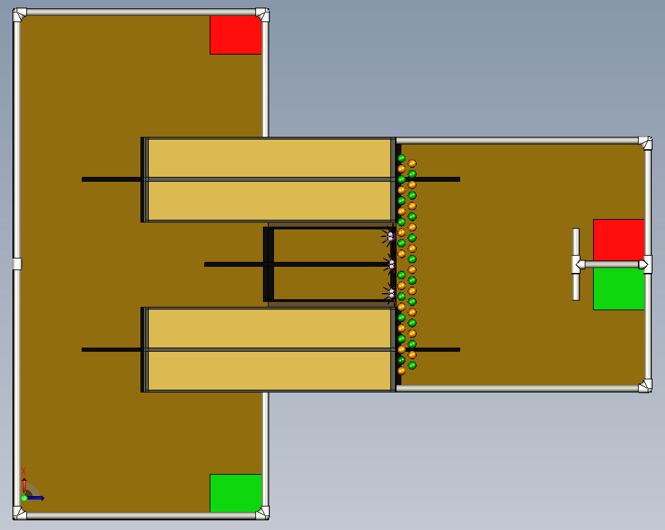
Lucky
Lucy
Bouncer
Lower Circle Path
Upper Path
Lower Direct Path

