Beyond Botball 2009
Planning

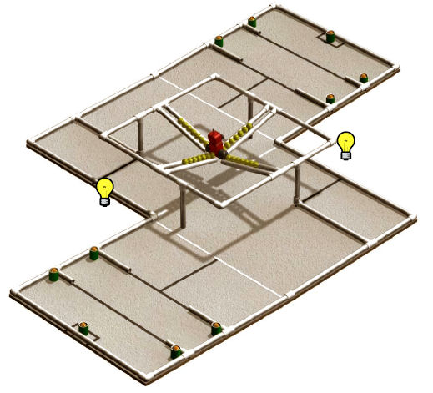

We are planning three robots:
- Golfball/BotGuy Pusher - Create with XBC
- House Grabber - XBC
- Competition Blocker - CBC

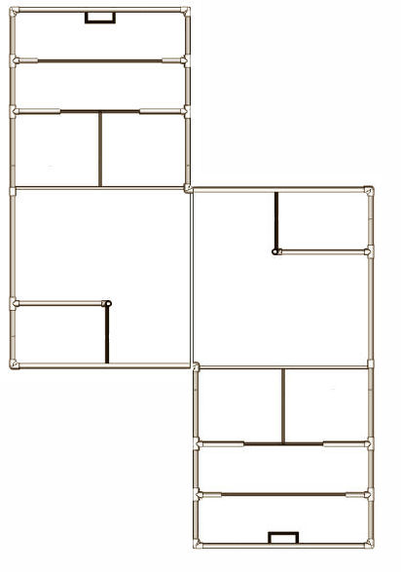
Golfball/Botyguy Pusher
1
2
3
4
5

Navigation Plan for Golfball/Botyguy Pusher
Normal straight speed 8in/sec, we may increase speed in competition.

Phase 1
Step 1
Pre Action: close arms fully
Drive: straight
Drive Condition: none
Time: 3sec
Stop Condition: either rear line sensors black
Post Action: turn left 40 degrees

Step 2
Pre Action: Botguy arm up
Drive: straight
Drive Condition: none
Time: 2sec
Stop Condition: none (timer only)
Post Action: knock down Botguy; wait for golf balls to empty; Botguy arm down

Step 3
Pre Action: turn right 55 degrees
Drive: straight using jerking to clear bump
Drive Condition: none
Time: 4.5sec
Stop Condition: none (timer only)
Post Action: turn right 70 degrees

Phase 2
Step 4
Pre Action: locate house
Drive: straight using jerking to clear bump
Drive Condition: keep house centered
Time: 5.5sec
Stop Condition: both front line sensors black
Post Action: open arms 160 degrees

Step 5
Pre Action: none
Drive: straight
Drive Condition: none
Time: 2sec
Stop Condition: both front line sensors black
Post Action: pick pom from house, and throw way

Golfball/Botyguy Pusher XBC Ports

// Starting Light = analog 2
//
// Line Left Front = analog 5
// Line Right Front = analog 6
// Line Left Back = analog 3
// Line Right Back = analog 4
//
// Grabber Left Arm = servo 2
// Grabber Right Arm = servo 3
// Botguy Grabber = servo 1
// Pom Remover = servo 0
//

Battery Levels
Maximum Create 16448 XBC 8.63
Off 12 hours Create 15808, XBC 8.49
Off 24 hours Create 15693, XBC 8.24

Notes

Issue | Date | Comment
Can the Create push 28 golf balls up the incline to the top? | 5/9/2009 | The first run with all balls was a success. The create easily jammed all balls in the top section, with several in the gated area.
Can the Create camera see the single green house from the bottom of the incline, and use it as a drive target? | 5/9/2009 | The camera sees a blob of about 500 pixels. May move the camera forward and higher. I am afraid Botguy in the net may block the camera.
The downward looking line followers are not triggering at 130, which is about half way between 0 and 255. | 5/9/2009 | The white board seems to scatter light, requiring a low discriminating value of around 60. I need to shield the rear sensors better
Can a simple pusher knock the Botguy off the ball holder, into the net, and release the balls? | 5/16/2009 | We are planning to push Botguy down through the hole where the balls run out. Botguy will get caught in the wire mesh. The balls will bounce around and off Botguy, but end up on the table under Botguy.
Do we need to use the camera to target the Botguy or is dead reckoning good enough?

House Grabber
2
1
3
4
5

6
7
8

House Grabber XBC Ports

// Starting Light = analog 2

Competition Blocker

1
Competition Blocker CBC Ports

// Starting Light = analog 2

