Rocket Lesson Plan Competition
Division II: Informal Instruction Teams

Robert Ekman, Advisor
Exploring Program Post 1010
Gaithersburg, MD

April 19, 2007

Explorer Post 1010 (http://exploring.external.lmco.com/) is an out-of-school work place program that is focused on giving high school students a perspective on careers in science, technology, engineering and math. The program meets weekly throughout the year with about 50 high school students from over 15 local high schools. Over 300 teens have participated in the program over the past ten years. It is a volunteer, non-profit organization, sponsored by Lockheed Martin (http://www.lockheedmartin.com/) in Gaithersburg Maryland, and formed under the national Learning-for-Life organization (http://www.learning-for-life.org/exploring/index.html).

Explorer Post 1010 is involved in a variety of engineering programs and projects featuring training, skill development, and service projects, such as robotics and rocketry. This is their third year in the Team America Rocketry Challenge (TARC). In the first year (2005) they had one team which failed to qualify but learned a lot about model rocketry. In 2006 they had two teams, both qualified and one went to the National Flyoff. In 2007, they have three teams and all three have been invited to the National Flyoff. Only one teenager remains from the first year team, but they have passed along lessons from year to year. The program advisors have been able to use resources from year to year and increase resources as interest has grown.

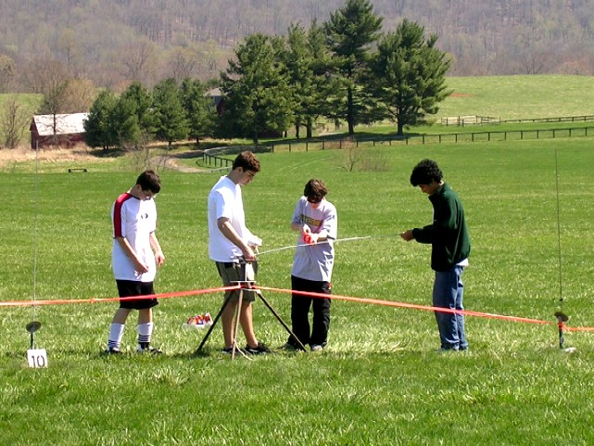
Cooperative Working Atmosphere
Since the program draws teens from many different schools, most of the teens do not know each other outside of the program. Through the many meetings and Internet based communications, they have developed a cooperative working relationship. Their interest in and the competitive nature of TARC has created respect for teens from different schools and communities across our county.

Many elements have led to the increase in interest and success of the TARC teams, but the backbone of the program has been the publishing of events and results on the post’s web site. The teams have spent time and effort to capture the results of most lunches and developments within a few days of the event. When they meet after a launch, they use the data, pictures, and videos collected as a source for analysis and improvements. They take time to document their objectives and lessons for the launch event.

The web site is more than just a recording activity. It provides a source of help from the advisors and adult support who post to it regularly. It also helps with communication with the parents and friends, especially with activity status and calendar of events. Not all members can come to all events, so the web pages, email, and on-line design aids allow for members to make continuous progress outside of meetings.

Participation by Females and Minorities
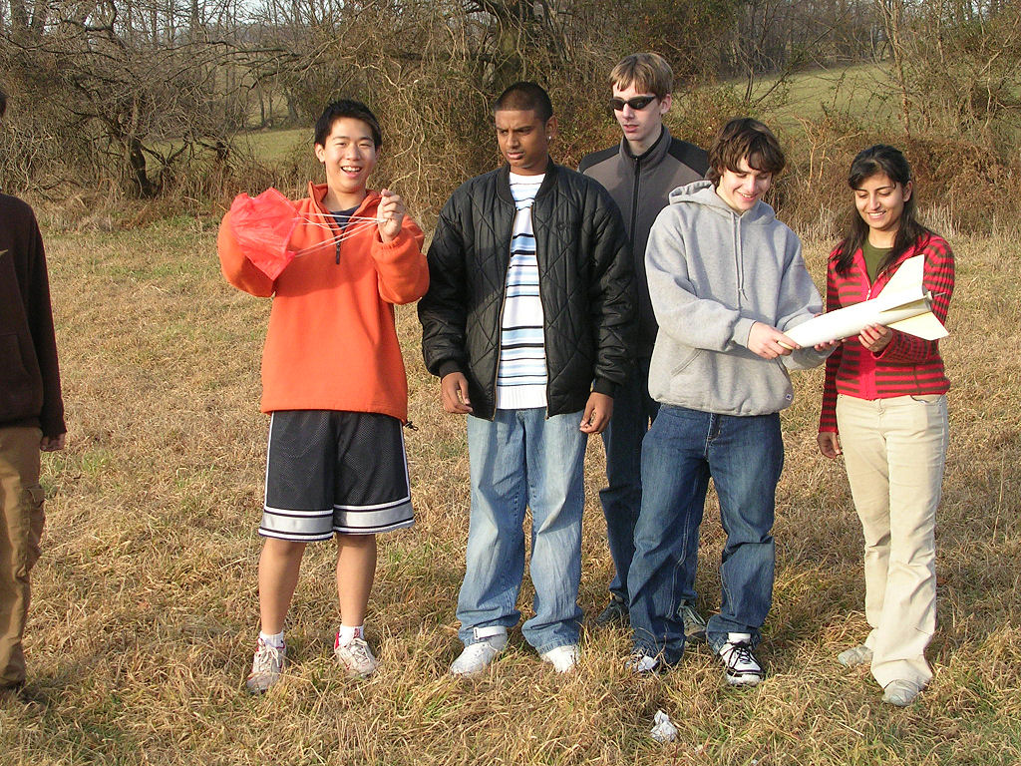
Explorer Post 1010 has not had good success in attracting and keeping females in the program. We have had some success in involving minorities, especially teens with Asian and Hispanic ancestry. The program is open to all high school students, and the few girls who participate do seem to enjoy the program. They usually become leaders. We make a pointed effort to invite girls, but since we focus on ninth and tenth grades for new members, most girls have already fled from engineering careers. The current thinking from people who have studied the issue is that girls move towards professional careers in medicine and law before they start high school.

Lesson Plans
The Team America Rocketry Challenge is a well define and operated program for giving teenagers an experience in engineering. It includes the engineering process elements of design, development, test, evaluation and project management. The teams run through these stages in a cyclic manner following a defined schedule to the final event. Our program objective is to have teens who are interested in engineering careers to experience this cycle using leadership and teamwork. TARC is very well suited for this objective.

Several tasks and technologies within the TARC program are very effective in demonstrating the test and evaluation phases of the engineering process. The information gathered during a launch is critical to the evaluation of the rocket and subsequent improvements. We have found three aspects of TARC that create a great learning activity.

Use of the Altimeter
The recording altimeter has proved to be a tremendous aid in creating data on rocket behavior and the launch. With the data plotted on their computer the TARC teams are able to see ignition, parachute ejection and landing of their rocket in great detail. The ballistic curve and parachute decent slope provide for the application of algebra to a real event. The teens learn to appreciate this by using the data during the evaluation phase. They are able to adjust parachute size and engine model as they narrow in on the TARC objective.

The following two graphs plot the altimeter data from two launches of the same rocket on the same day using the same model engine and parachute. The objective was to fly to 850 feet and land 45 seconds after launch. The first launch was a little low, but took to long to land. The second flight was even lower, but landed too soon.
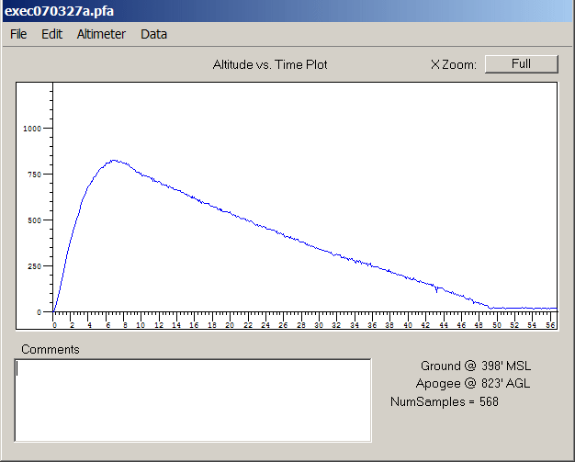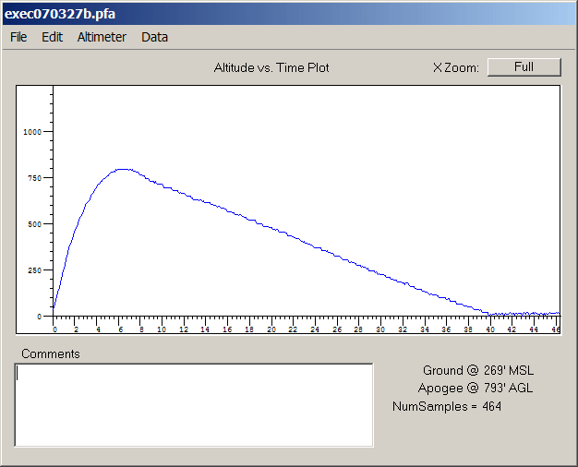

It is easy to see the ballistic curve and the slope of the parachute landing. The possible engine characteristics are plotted in the following graphs. The engine they used was the E18W.
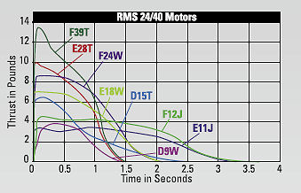

The question to the students is what should they do now? Change the engine? To which one? Decrease the rocket weight? How much? Change the parachute size? How much? Delay the ejection charge? How much?

Video Recording of the Launch
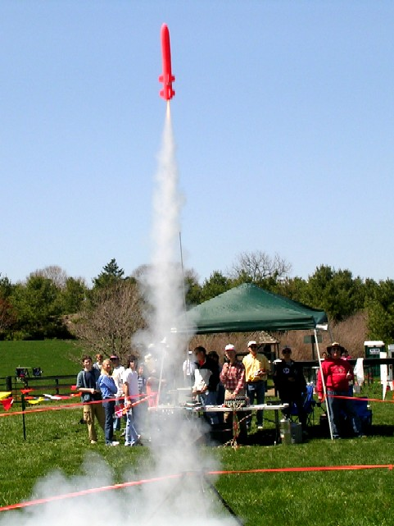
Rocket flights occur fast and the teens are not able to see much of what actually happens. Our TARC teams have taken video recordings of almost every launch and many of the recoveries. They used a variety of camcorders and video techniques. The payback is very valuable. The teams are able to replay the launch in slow motion and frame-at-a-time to see how the rocket left the launch tower. In some cases, they are able to see the landings, although distance makes it difficult to see and locate. The video and audio recordings are also able to document the time between launch and landing, giving an additional data point besides the stop watch recordings.

Weather Effects
The effects of weather (wind, humidity, temperature) are significant in a TARC rocket launch and the effort to meet the TARC objectives. This has proved to be the most difficult aspect to quantify and predict. The TARC teams were able to observe the effects but were not able to consistently counter them. The teams were able to straighten the flights to some degree through launch rod angle, but were not able to correlate other weather variables with performance. This is a topic that may be explored in future TARC projects.

Respectfully submitted,

Robert Ekman
Lockheed Martin
700 N. Frederick Ave
Gaithersburg, MD 20879
301-240-7625
bob.ekman@lmco.com

