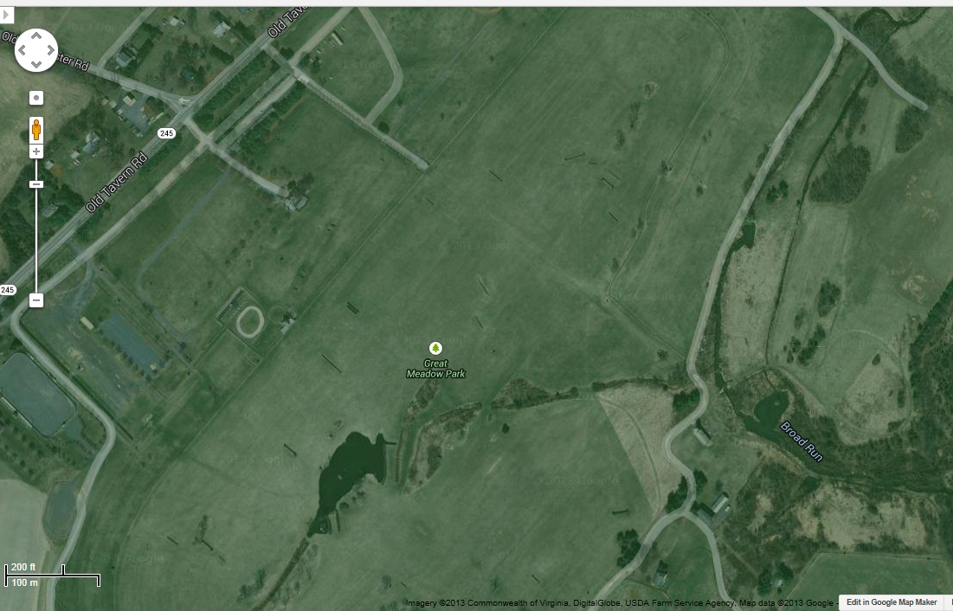

Inner Circle: wind = 5mi/hr, altitude = 800ft, descent = 16ft/sec, distance = 366ft
Outer Circle: wind = 10mi/hr, altitude = 800ft, descent = 16ft/sec, distance = 732ft

